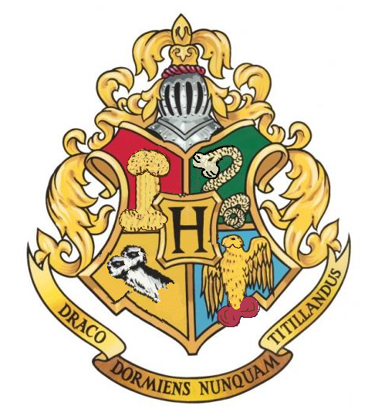

69 ¾

HOGWARTS EXPRESS

